***Assignment 1 – File System Management***

1. List out 5 files in your system which consuming most of the disk space

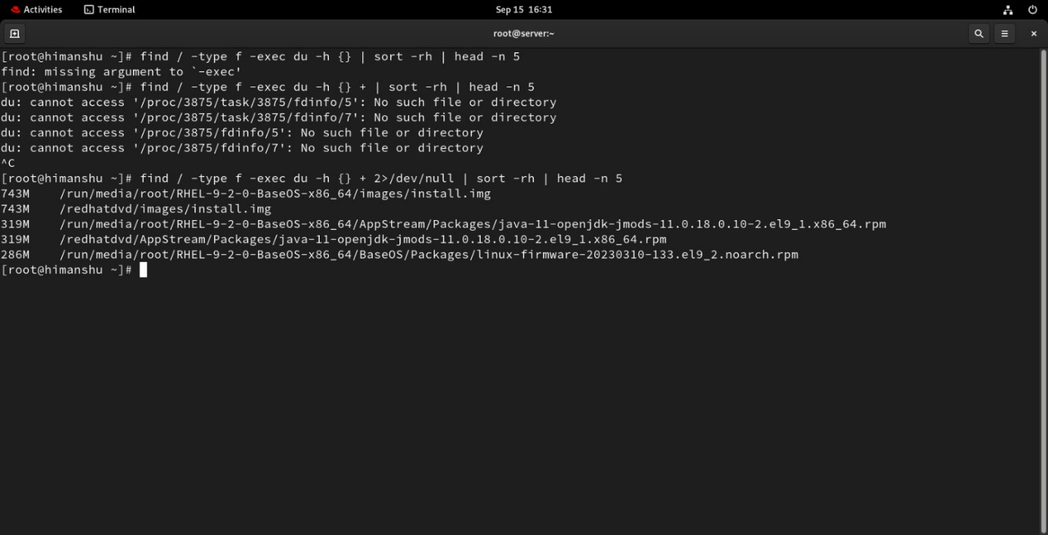

1. Create one common folder in such a way that anyone can create files inside that independently and should not be able to delete other users files from that common folder.

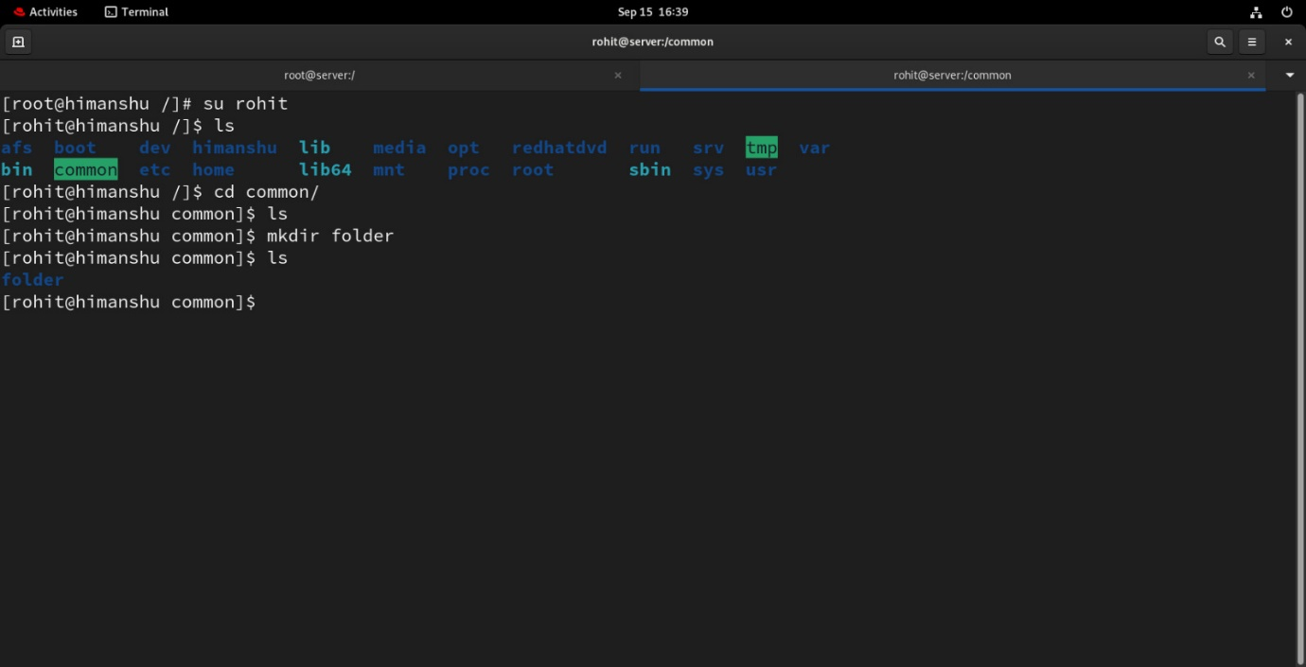

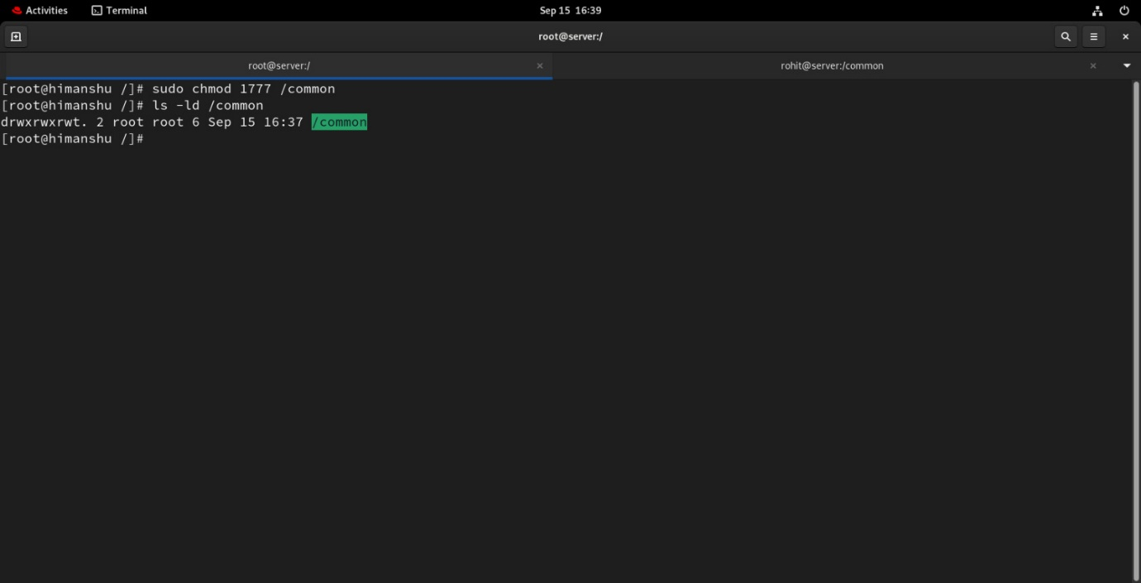

3) Create user name "shubham" and add that user in the group "adm" a) Create folder /data , change owner and group as "root:adm b) Change /data permission such a way that user can able to write data in this folder and ownership of files or folder which you creates in this folder should be same as parent folder i.e /data folder permission (root:adm)

